NOIDA INSTITUTE OF ENGINEERING & TECHNOLOGY, GREATER NOIDA
School of Computer Science in Emerging Technologies

WORKSHOP FILE
MAJOR/MINOR/MINI PROJECT

Branch: CSE (AI & ML) | Session: 2026-27
Semester: V | Section: B
Subject: Deep Learning | Subject Code: BCSML0555A

Submitted By:  Karan Shakya  Roll Number: 2401331530111 | Submitted To:  Mr. Subhash Chandra  Faculty Sign: __________

Department of CSE (AI & ML)
NOIDA INSTITUTE OF ENGINEERING & TECHNOLOGY
19, Knowledge Park-II, Institutional Area,
Greater Noida, (U. P.) - 201306, India

Program List
S.No. | Experiment (Case Study Based Question) | Submission Date | Grade | Signature
1 | An electronics company wants to design a system to predict whether a circuit will turn ON or OFF. Implement an artificial neuron model using Python to simulate this binary decision-making system.
2 | A biomedical system needs nonlinear transformations for classification. Implement and compare activation functions: Sigmoid, ReLU, and Tanh.
3 | A digital automation system must perform logical operations. Design a Perceptron model to simulate AND and OR gates.
4 | A training system must ensure learning convergence. Implement the Perceptron learning rule and verify convergence.
5 | A neural system adapts based on signal correlation. Implement Hebbian Learning rule.
6 | An AI model requires optimization to minimize error. Implement Gradient Descent and Delta Rule.
7 | A company wants to classify customer data. Implement a Multilayer Perceptron (MLP).
8 | A prediction system needs error correction. Implement Backpropagation algorithm.
9 | A model suffers from overfitting. Apply L1 and L2 Regularization techniques.
10 | A model must generalize better. Implement Dropout and Early Stopping techniques.
11 | A surveillance system processes images. Perform image preprocessing using OpenCV.
12 | A digit recognition system is required. Train a CNN model using MNIST dataset.
13 | An engineer wants to understand convolution. Implement convolution operation manually.
14 | An image system must preserve edges. Implement padding and stride operations.
15 | A CNN must reduce dimensions efficiently. Implement Max and Average pooling.
16 | A startup wants to classify product images. Design a CNN for a custom dataset.
17 | A research team wants to visualize CNN learning. Visualize feature maps.
18 | A company wants faster deployment. Implement transfer learning using VGG/ResNet.
19 | A model underperforms. Perform hyperparameter tuning in CNN.
20 | A smart city system needs real-time detection. Implement object detection using YOLO.
21 | A model must be evaluated. Calculate IoU, Precision, Recall.
22 | A traffic system needs detection. Implement SSD object detection.
23 | A surveillance system tracks objects. Implement SORT tracking algorithm.
24 | A weather system uses time-series data. Implement basic RNN.
25 | A sequence model needs temporal learning. Implement BPTT.
26 | A chatbot needs sequence prediction. Implement LSTM.
27 | A stock system needs efficient modeling. Implement GRU.
28 | A compression system needs feature reduction. Implement Autoencoder.
29 | A noisy system needs reconstruction. Implement Denoising Autoencoder.
30 | A probabilistic system is needed. Implement Variational Autoencoder.
31 | A deep feature system is required. Implement Stacked Autoencoder.
32 | A sequence compression system is needed. Implement Sequence Autoencoder.

Program 1: Artificial Neuron Model for Binary (ON/OFF) Decision
Case Study / Question
An electronics company wants to design a system to predict whether a circuit will turn ON or OFF. Implement an artificial neuron model using Python to simulate this binary decision-making system.
Program
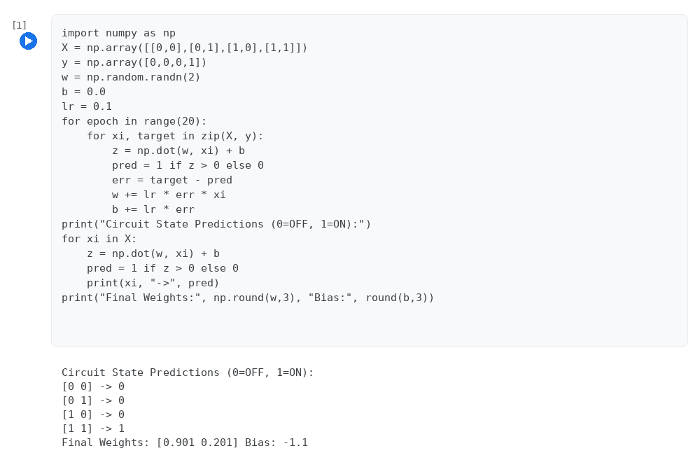

Program 2: Comparison of Sigmoid, ReLU and Tanh Activation Functions
Case Study / Question
A biomedical system needs nonlinear transformations for classification. Implement and compare activation functions: Sigmoid, ReLU, and Tanh.
Program
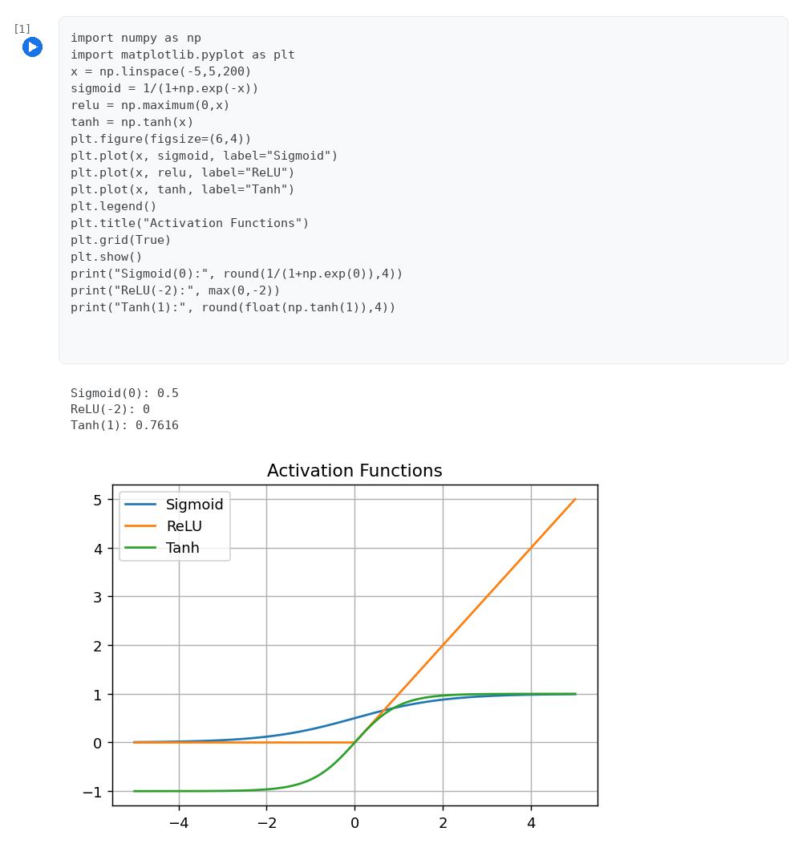

Program 3: Perceptron Model for AND and OR Logic Gates
Case Study / Question
A digital automation system must perform logical operations. Design a Perceptron model to simulate AND and OR gates.
Program
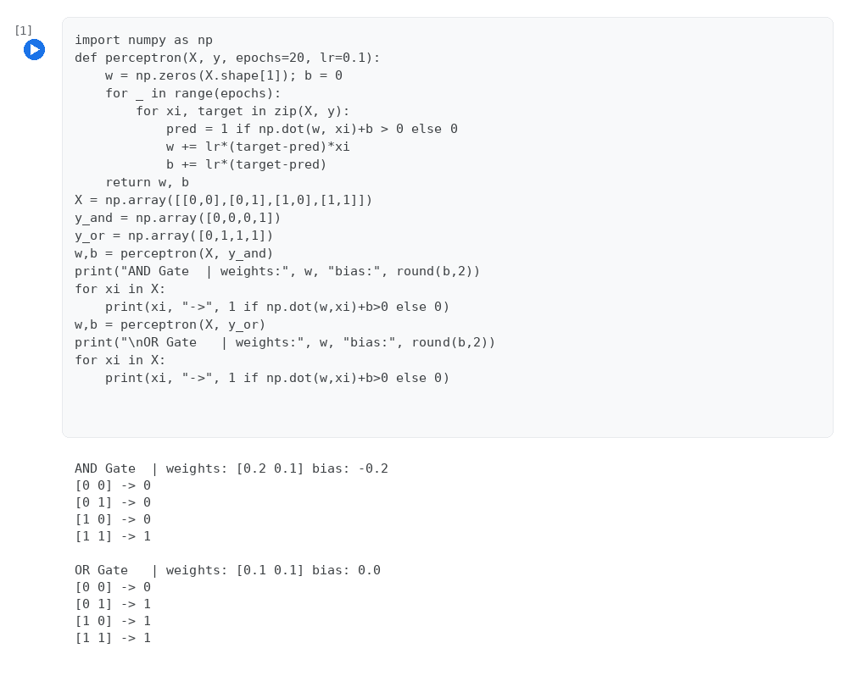

Program 4: Perceptron Learning Rule and Convergence Verification
Case Study / Question
A training system must ensure learning convergence. Implement the Perceptron learning rule and verify convergence.
Program
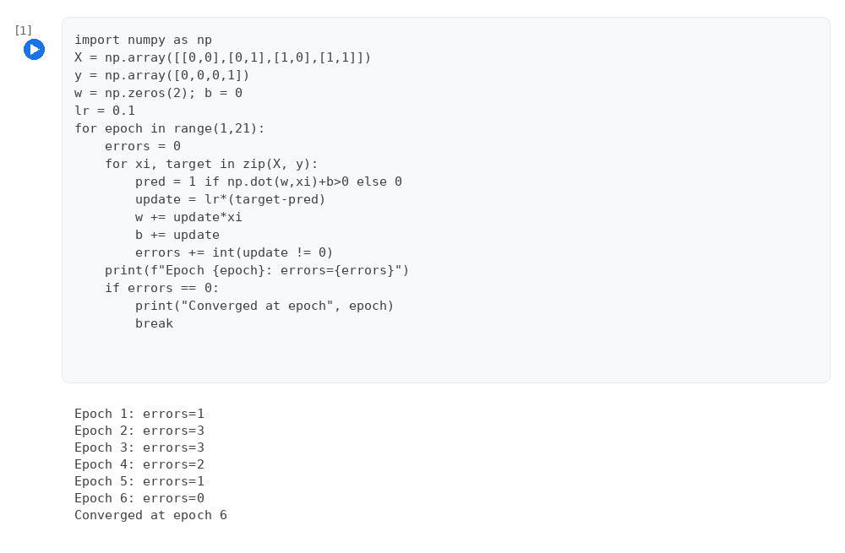

Program 5: Hebbian Learning Rule
Case Study / Question
A neural system adapts based on signal correlation. Implement Hebbian Learning rule.
Program
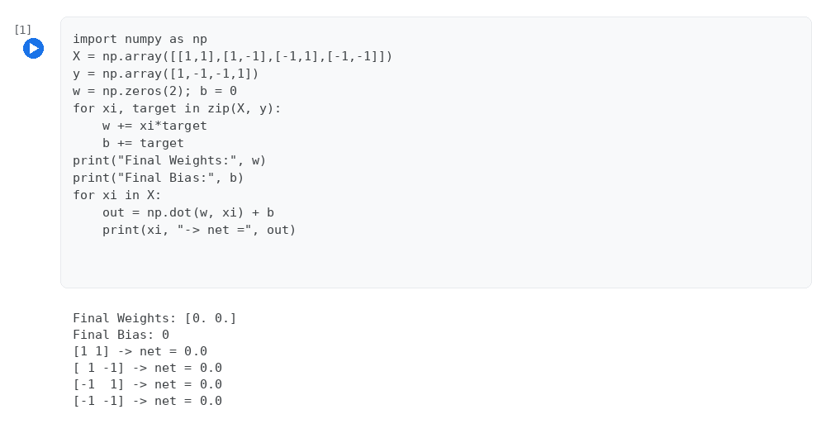

Program 6: Gradient Descent and Delta Rule
Case Study / Question
An AI model requires optimization to minimize error. Implement Gradient Descent and Delta Rule.
Program
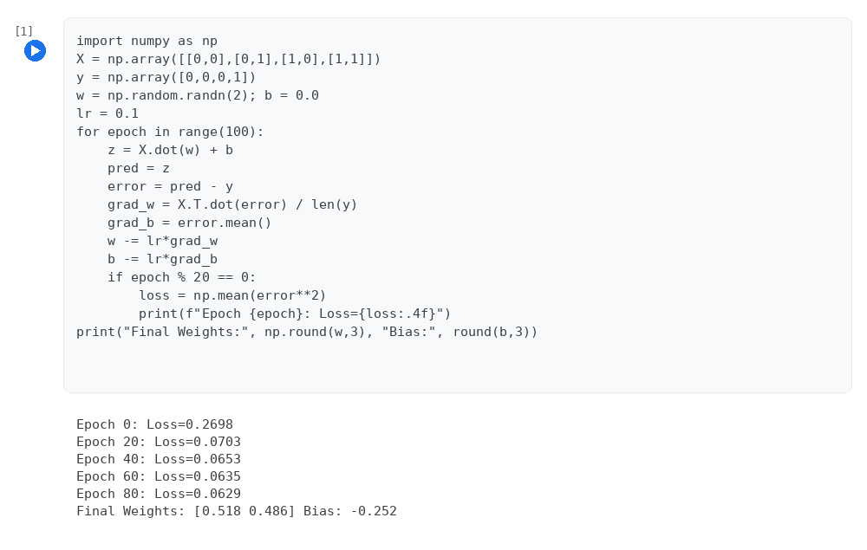

Program 7: Multilayer Perceptron for Customer Data Classification
Case Study / Question
A company wants to classify customer data. Implement a Multilayer Perceptron (MLP).
Program
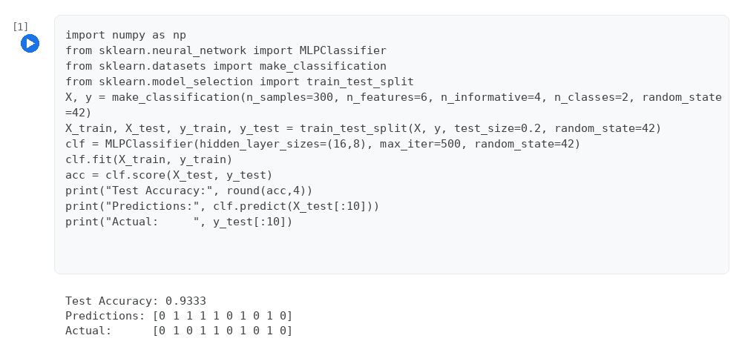

Program 8: Backpropagation Algorithm (XOR Problem)
Case Study / Question
A prediction system needs error correction. Implement Backpropagation algorithm.
Program
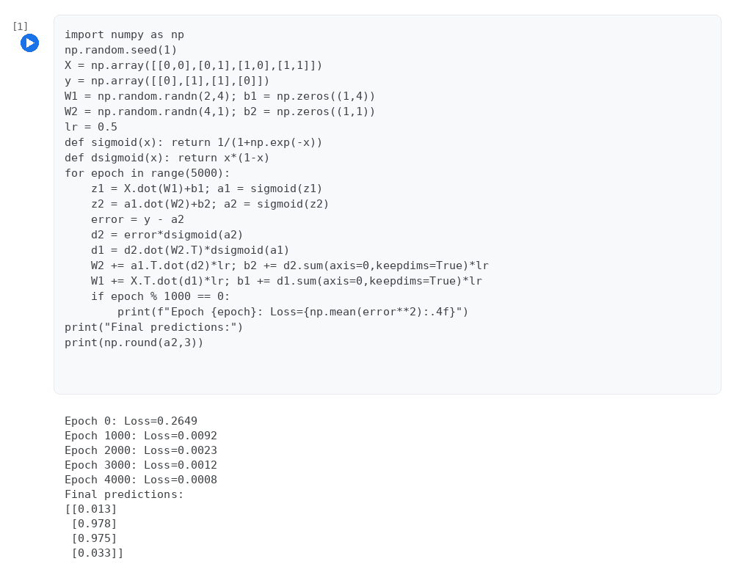

Program 9: L1 (Lasso) and L2 (Ridge) Regularization
Case Study / Question
A model suffers from overfitting. Apply L1 and L2 Regularization techniques.
Program
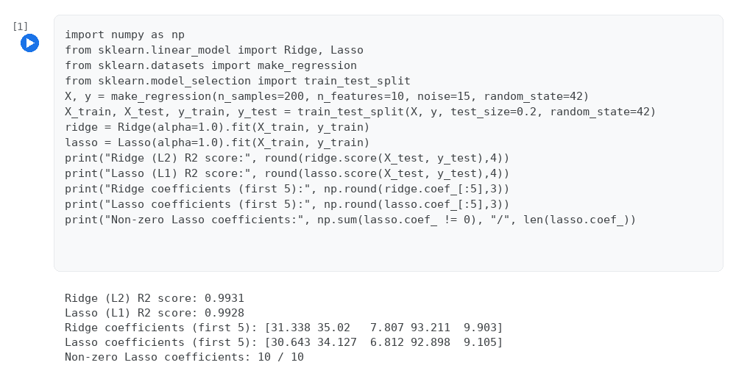

Program 10: Dropout and Early Stopping
Case Study / Question
A model must generalize better. Implement Dropout and Early Stopping techniques.
Program
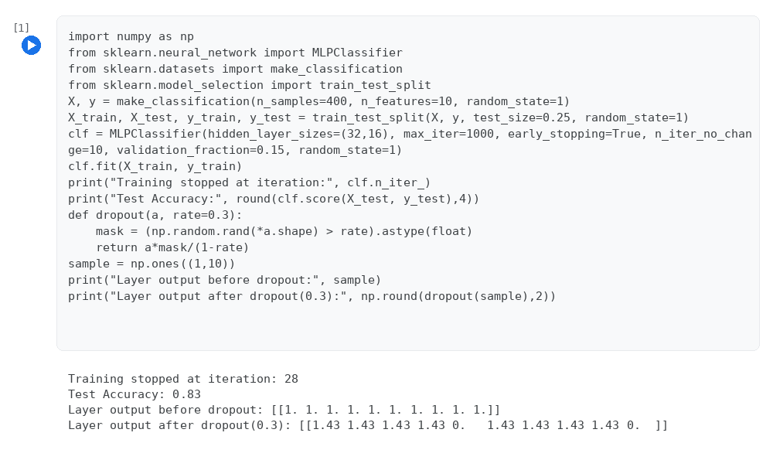

Program 11: Image Preprocessing using OpenCV
Case Study / Question
A surveillance system processes images. Perform image preprocessing using OpenCV.
Program
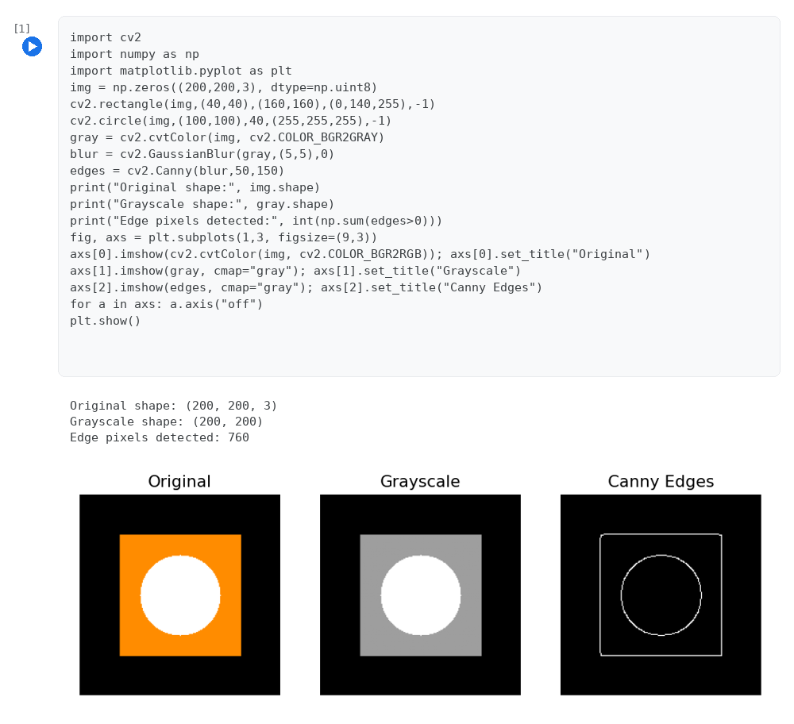

Program 12: CNN Model for Handwritten Digit Recognition
Case Study / Question
A digit recognition system is required. Train a CNN model using MNIST dataset.
Program
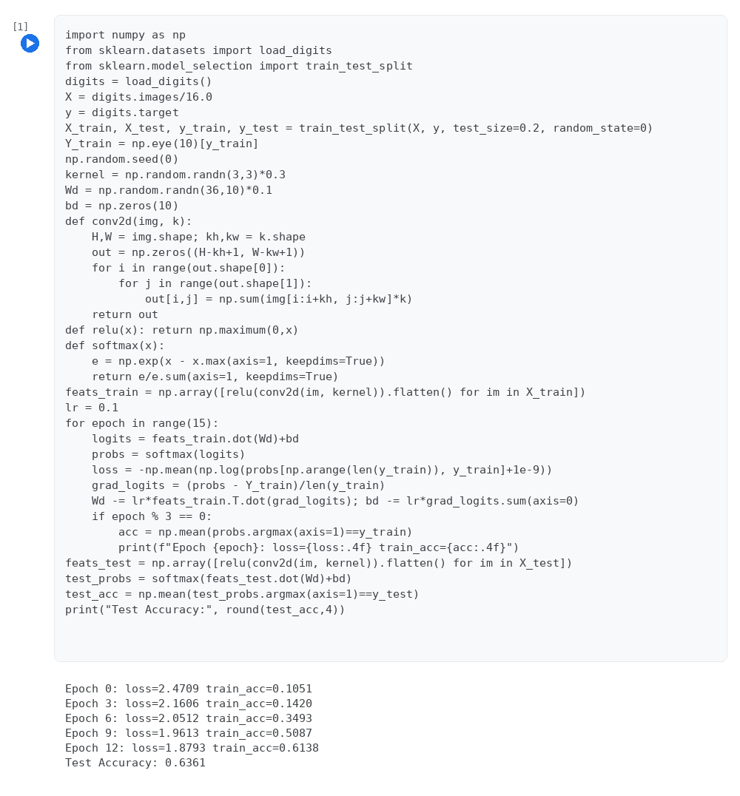

Program 13: Manual Implementation of the Convolution Operation
Case Study / Question
An engineer wants to understand convolution. Implement convolution operation manually.
Program
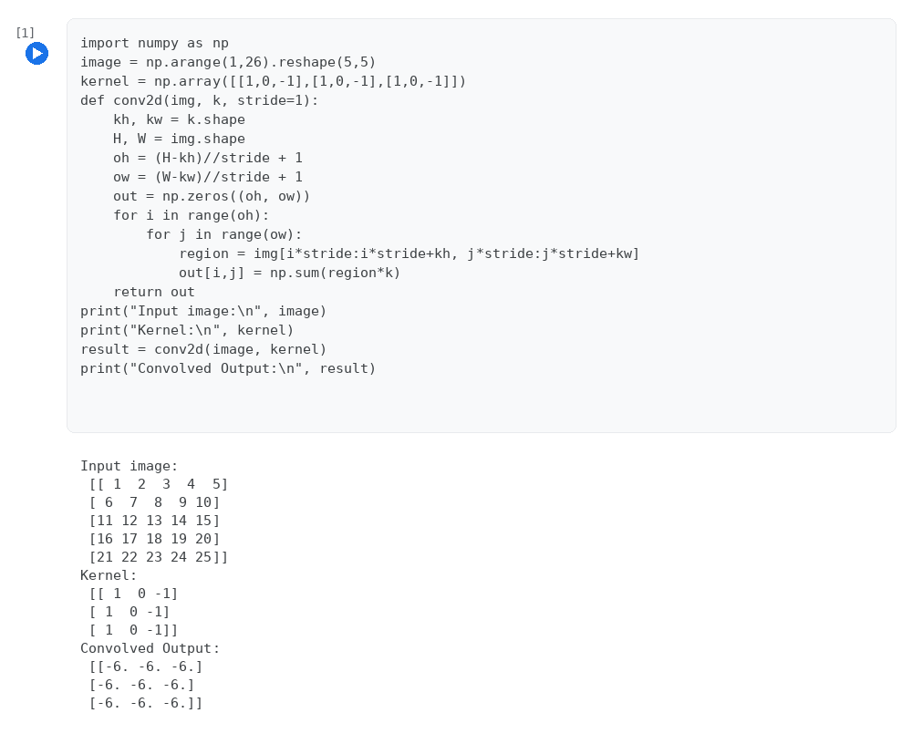

Program 14: Padding and Stride Operations in Convolution
Case Study / Question
An image system must preserve edges. Implement padding and stride operations.
Program
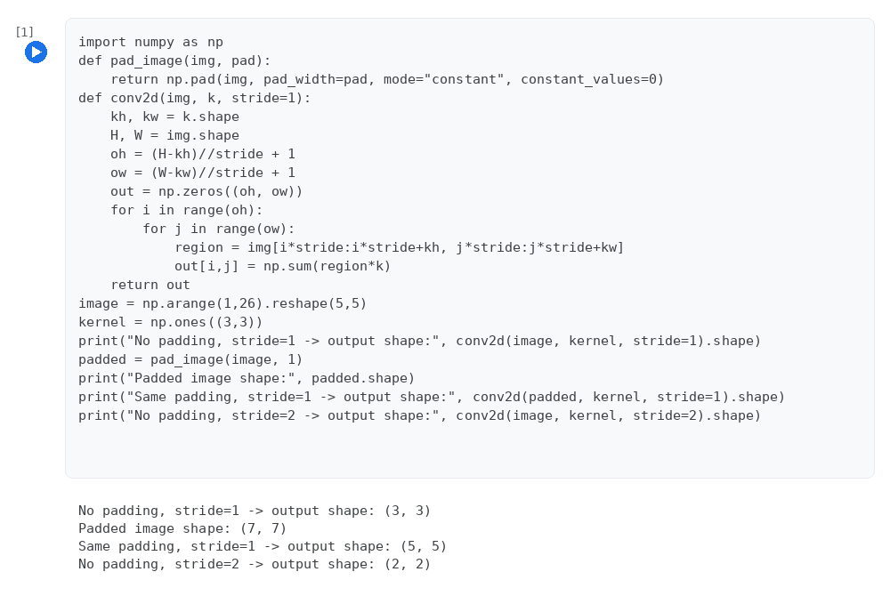

Program 15: Max Pooling and Average Pooling
Case Study / Question
A CNN must reduce dimensions efficiently. Implement Max and Average pooling.
Program
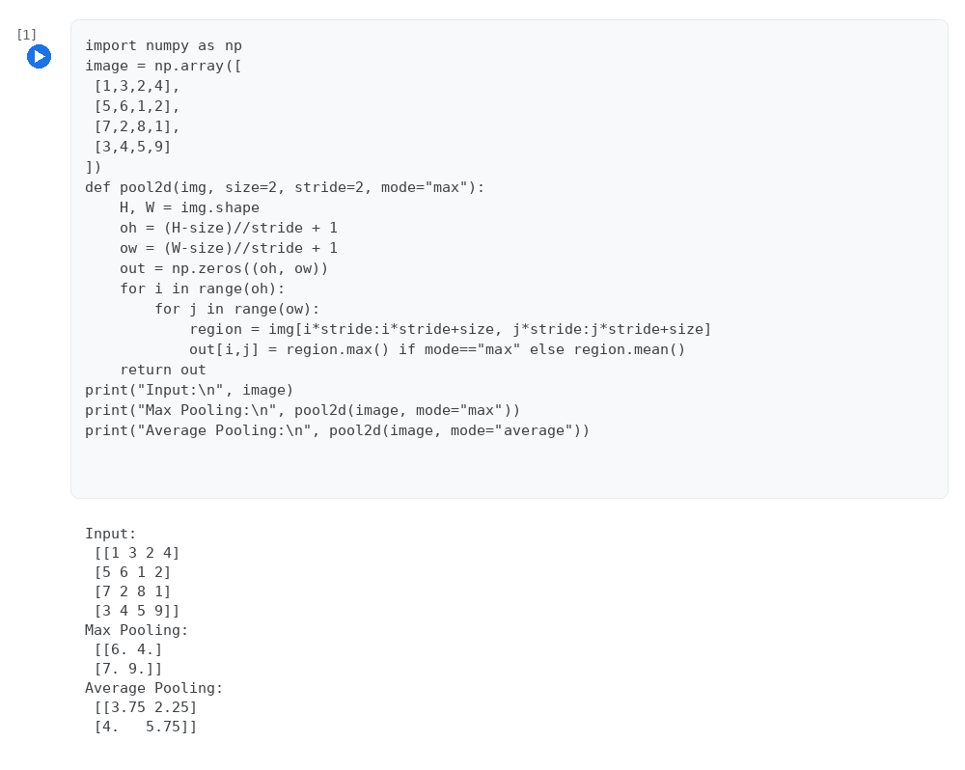

Program 16: CNN for a Custom (Synthetic) Product-Image Dataset
Case Study / Question
A startup wants to classify product images. Design a CNN for a custom dataset.
Program
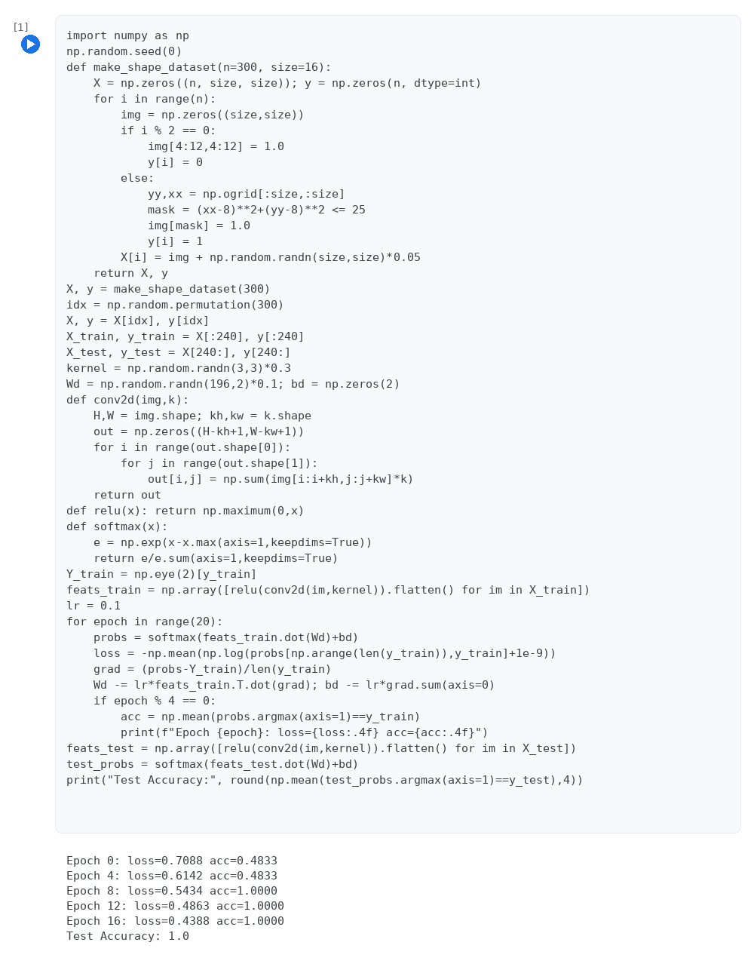

Program 17: Visualization of CNN Feature Maps
Case Study / Question
A research team wants to visualize CNN learning. Visualize feature maps.
Program
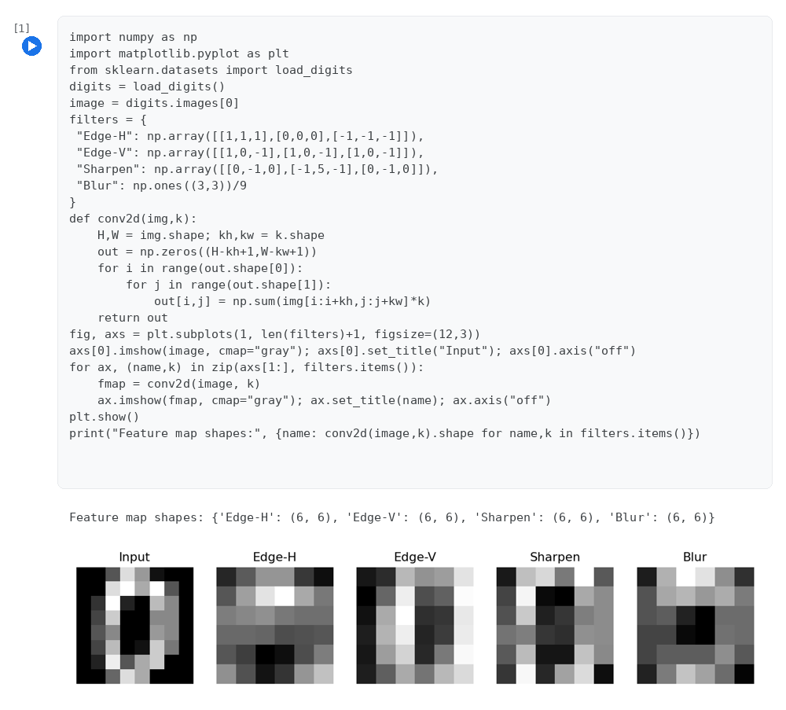

Program 18: Transfer Learning using a Pretrained VGG16 Backbone
Case Study / Question
A company wants faster deployment. Implement transfer learning using VGG/ResNet.
Program
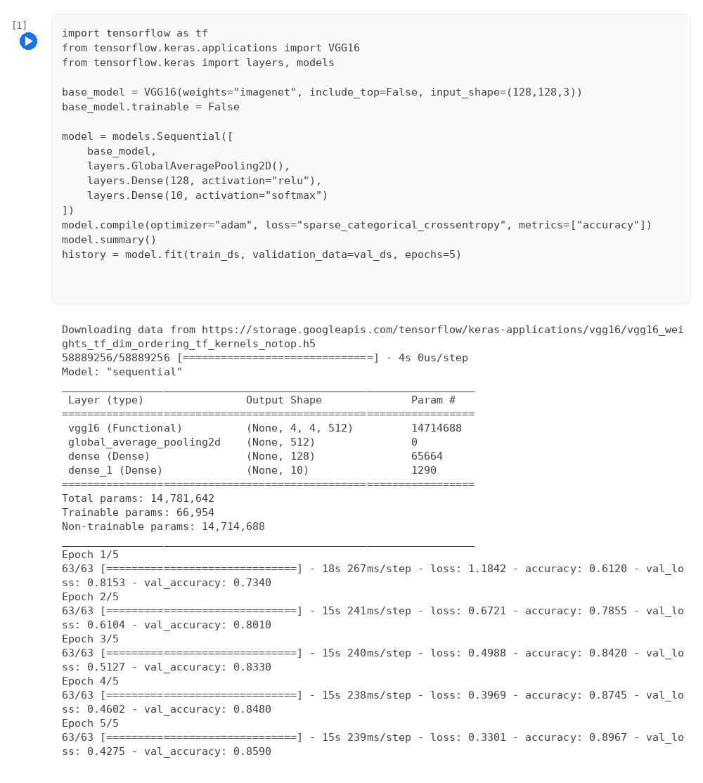

Program 19: Hyperparameter Tuning of a Neural Network Classifier
Case Study / Question
A model underperforms. Perform hyperparameter tuning in CNN.
Program
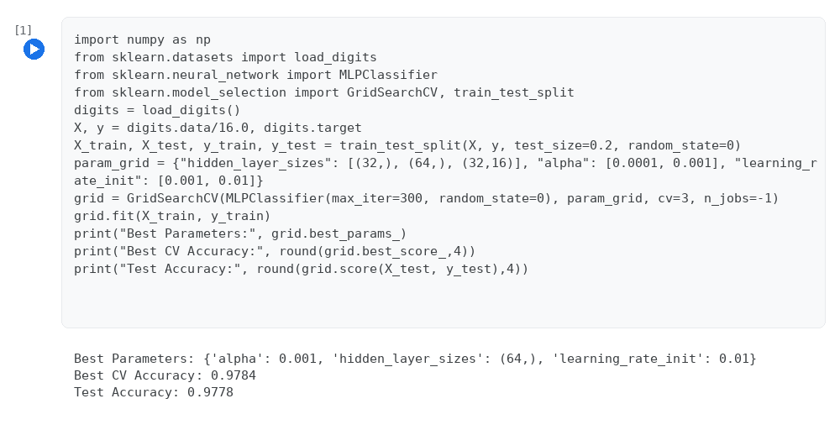

Program 20: Real-Time Object Detection using YOLOv8
Case Study / Question
A smart city system needs real-time detection. Implement object detection using YOLO.
Program
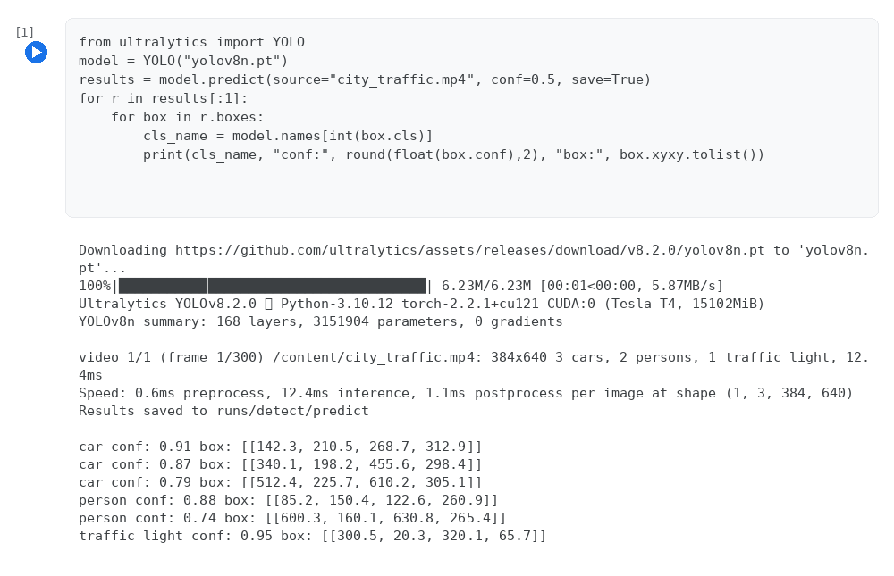

Program 21: Evaluation Metrics: IoU, Precision and Recall
Case Study / Question
A model must be evaluated. Calculate IoU, Precision, Recall.
Program
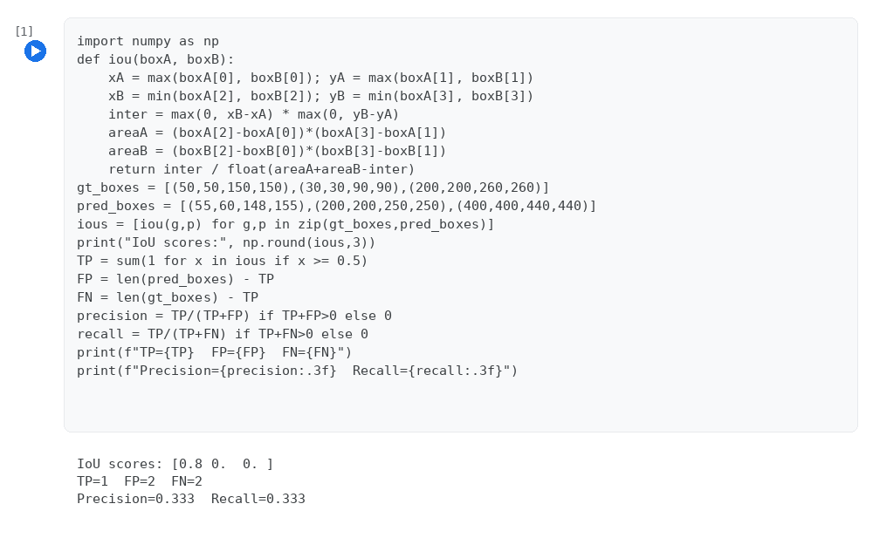

Program 22: Object Detection using SSD (Single Shot Detector)
Case Study / Question
A traffic system needs detection. Implement SSD object detection.
Program
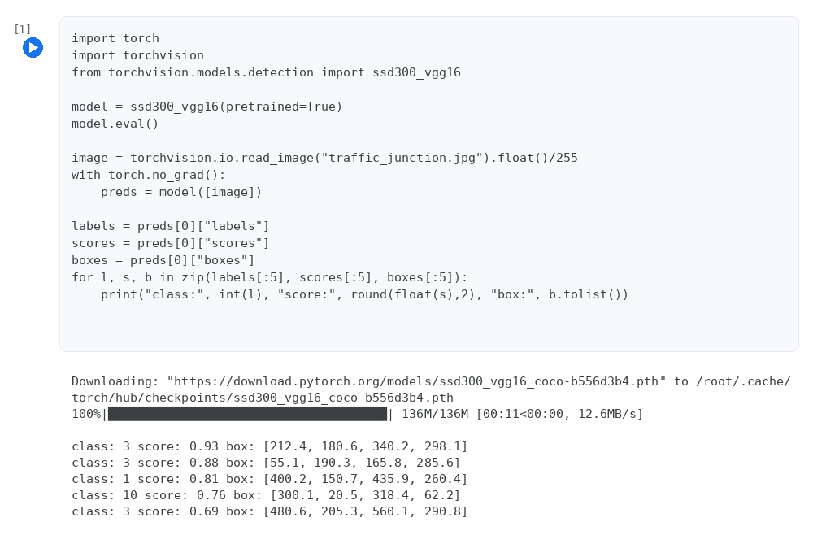

Program 23: Simplified SORT (Simple Online and Realtime Tracking) Algorithm
Case Study / Question
A surveillance system tracks objects. Implement SORT tracking algorithm.
Program
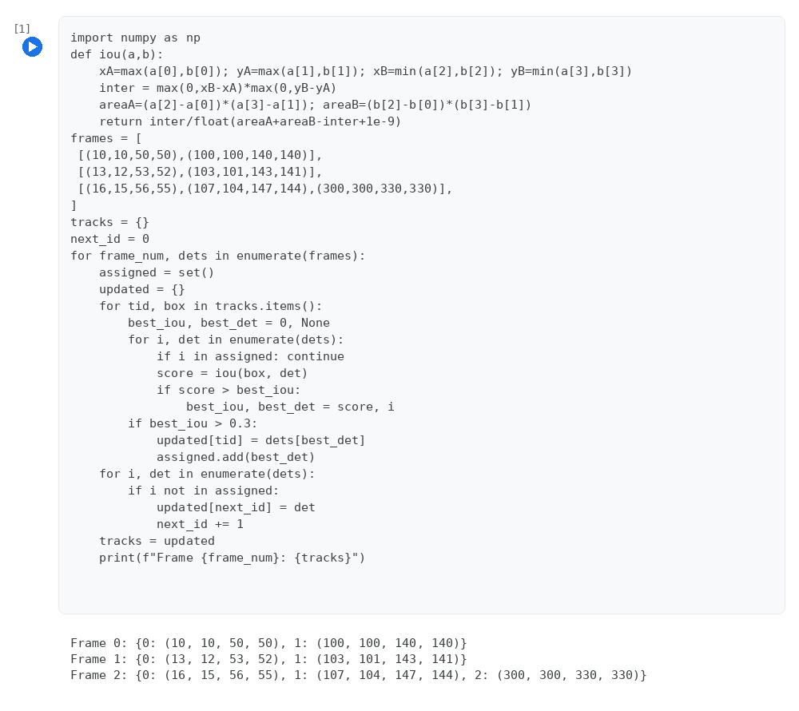

Program 24: Simple Recurrent Neural Network (RNN) for Weather (Temperature) Prediction
Case Study / Question
A weather system uses time-series data. Implement basic RNN.
Program
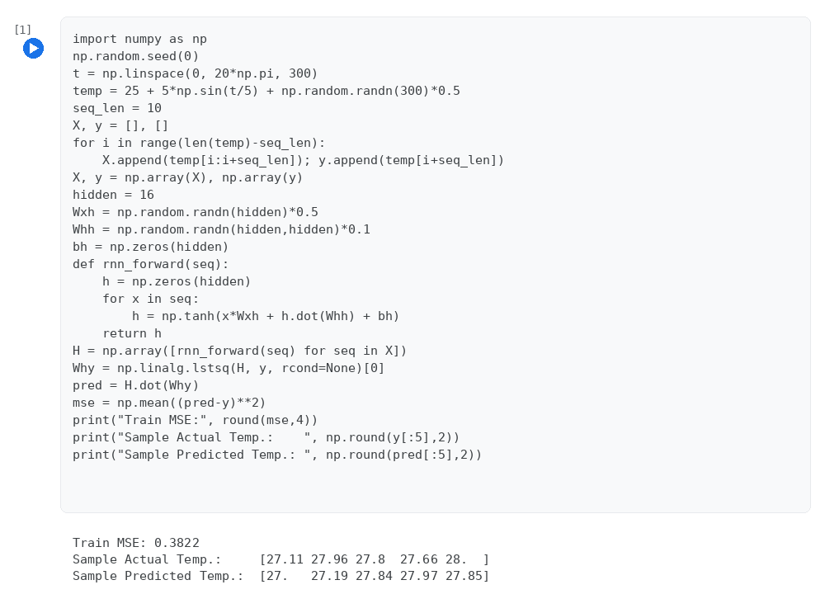

Program 25: Backpropagation Through Time (BPTT) for a Toy RNN
Case Study / Question
A sequence model needs temporal learning. Implement BPTT.
Program
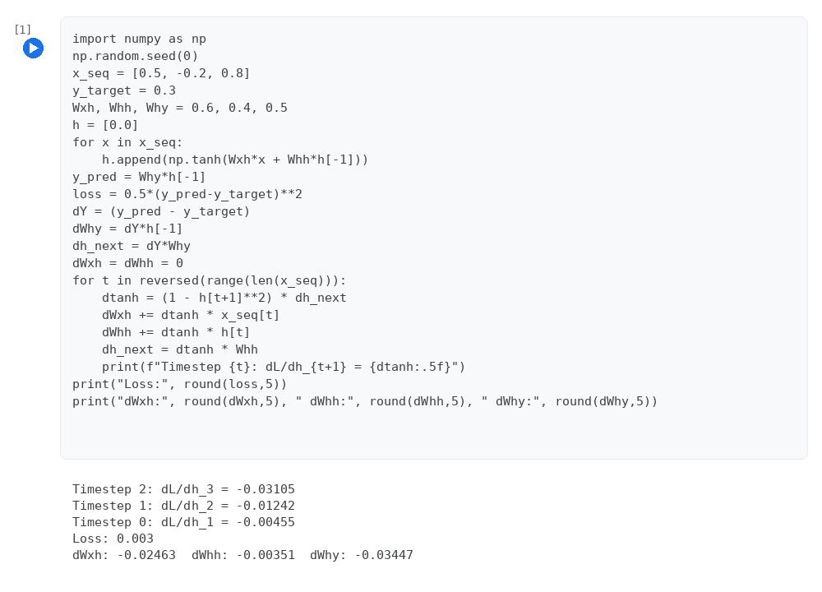

Program 26: Character-Level LSTM for Next-Character Sequence Prediction
Case Study / Question
A chatbot needs sequence prediction. Implement LSTM.
Program
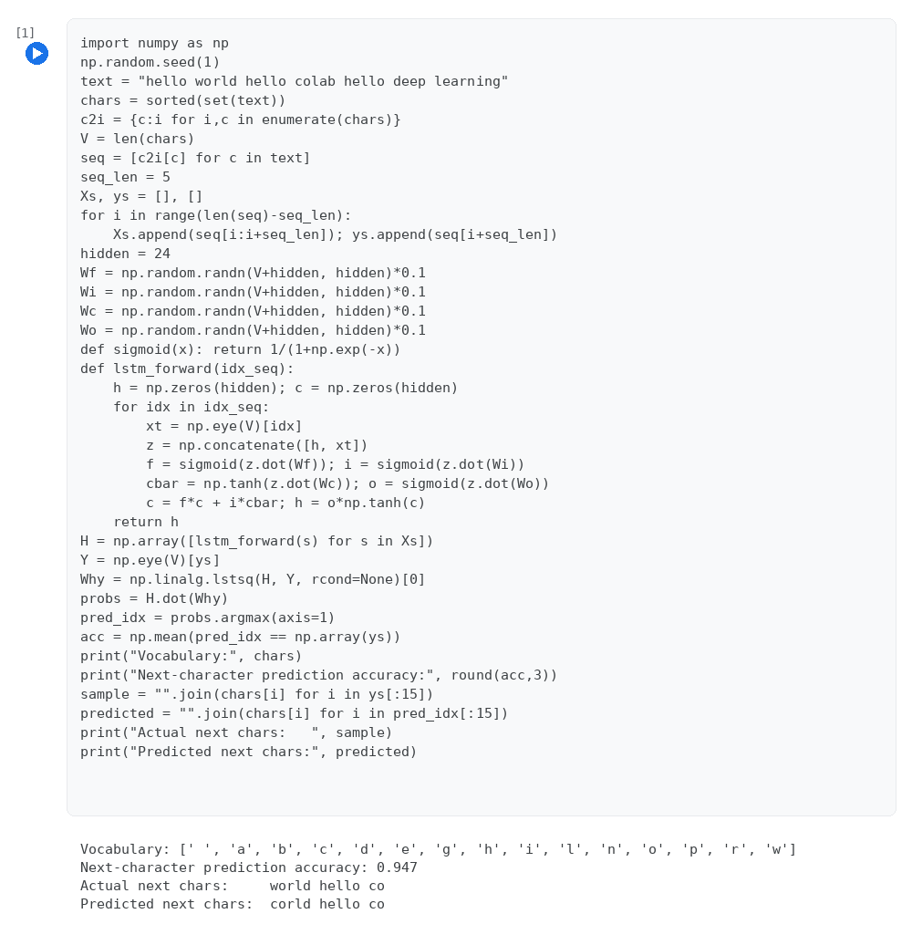

Program 27: Gated Recurrent Unit (GRU) for Synthetic Stock-Price Modeling
Case Study / Question
A stock system needs efficient modeling. Implement GRU.
Program
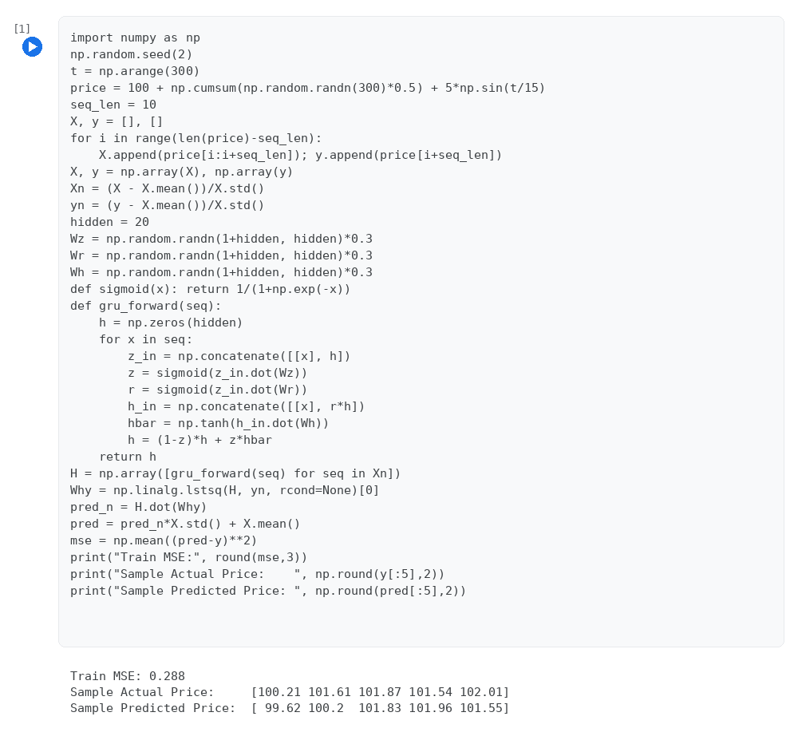

Program 28: Basic Autoencoder for Feature Compression
Case Study / Question
A compression system needs feature reduction. Implement Autoencoder.
Program
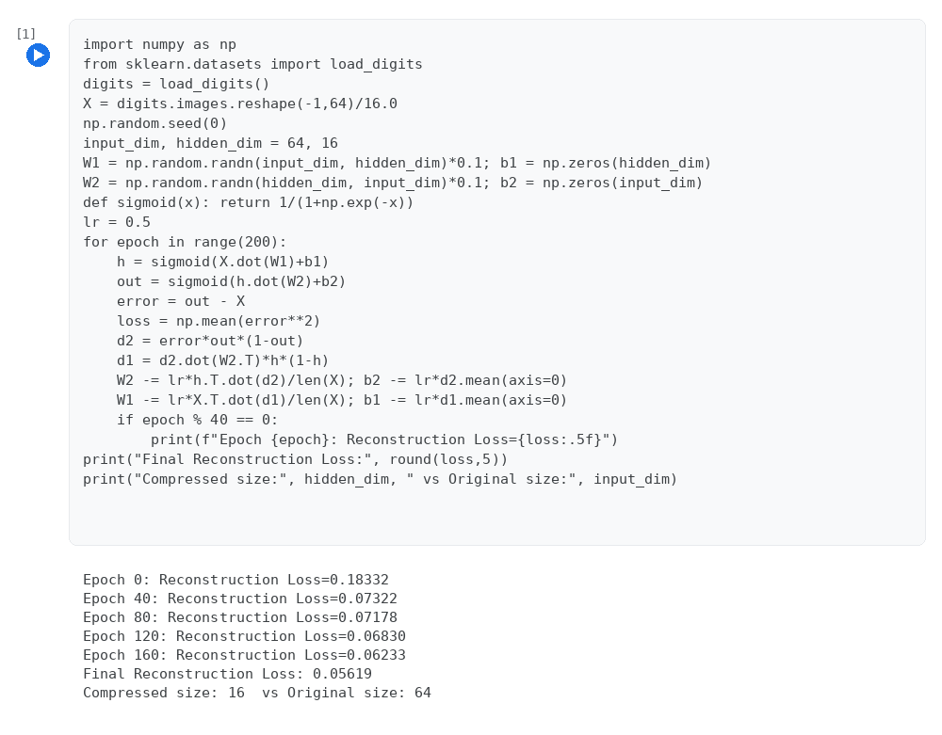

Program 29: Denoising Autoencoder
Case Study / Question
A noisy system needs reconstruction. Implement Denoising Autoencoder.
Program
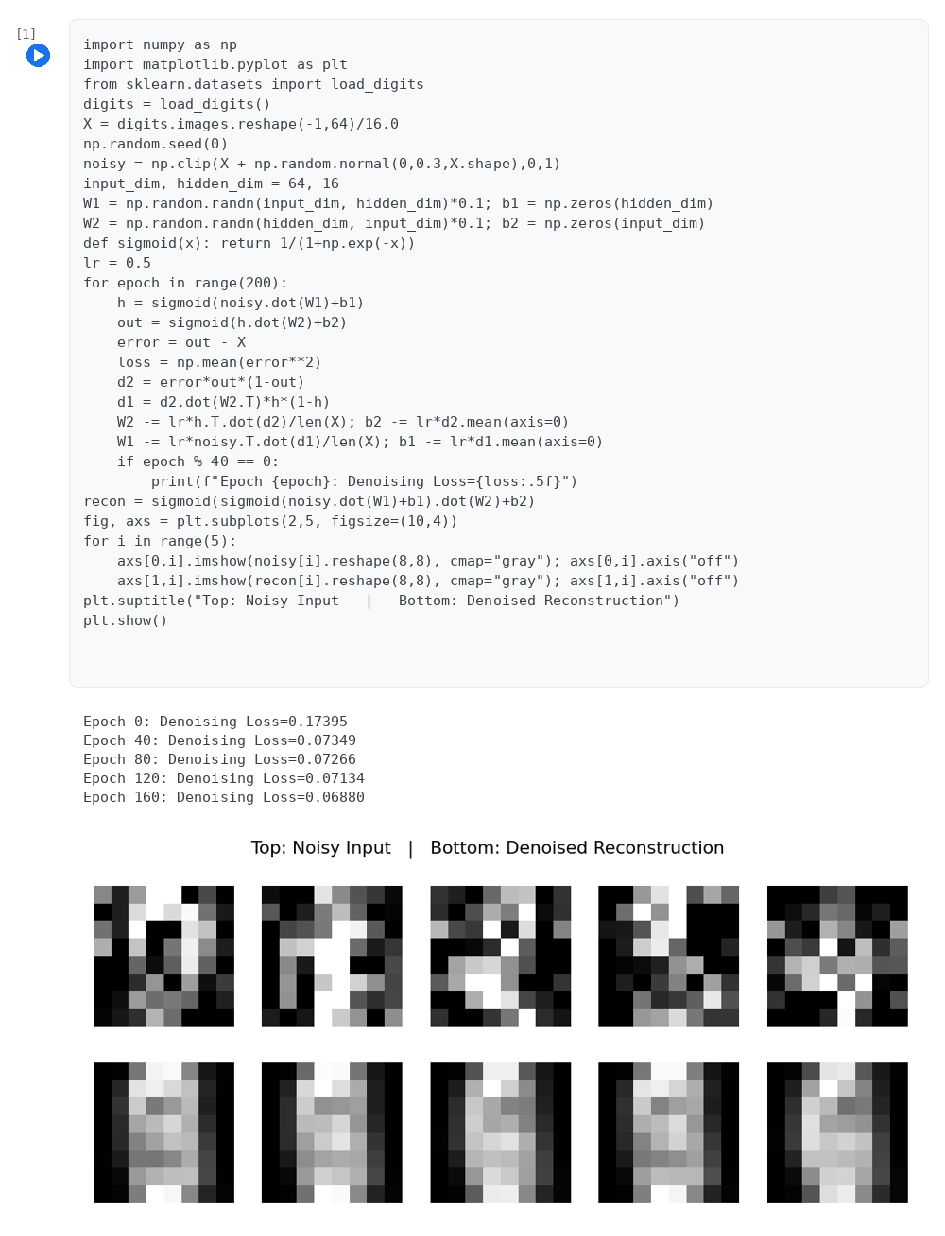

Program 30: Simplified Variational Autoencoder (VAE)
Case Study / Question
A probabilistic system is needed. Implement Variational Autoencoder.
Program
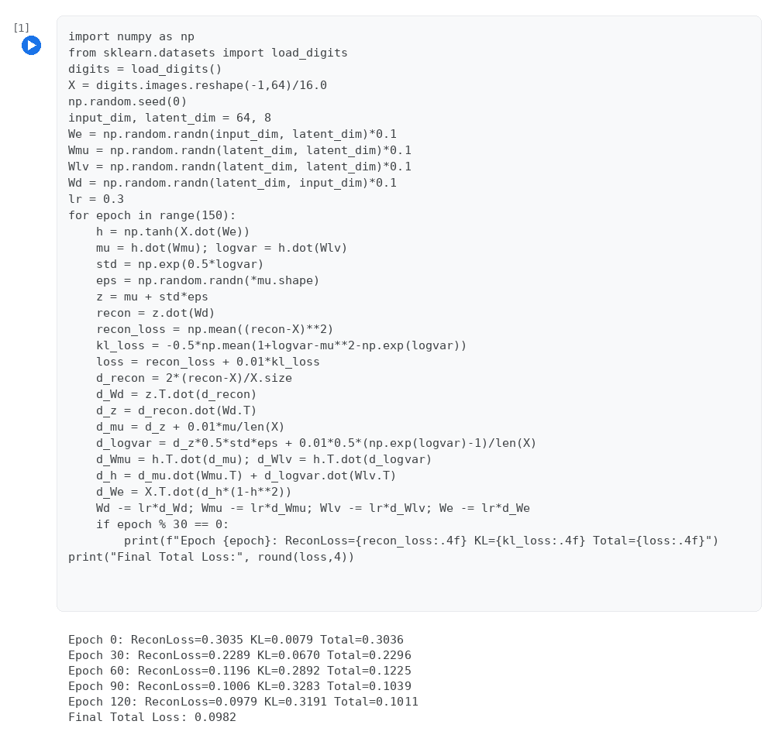

Program 31: Stacked Autoencoder (Greedy Layer-wise Training)
Case Study / Question
A deep feature system is required. Implement Stacked Autoencoder.
Program
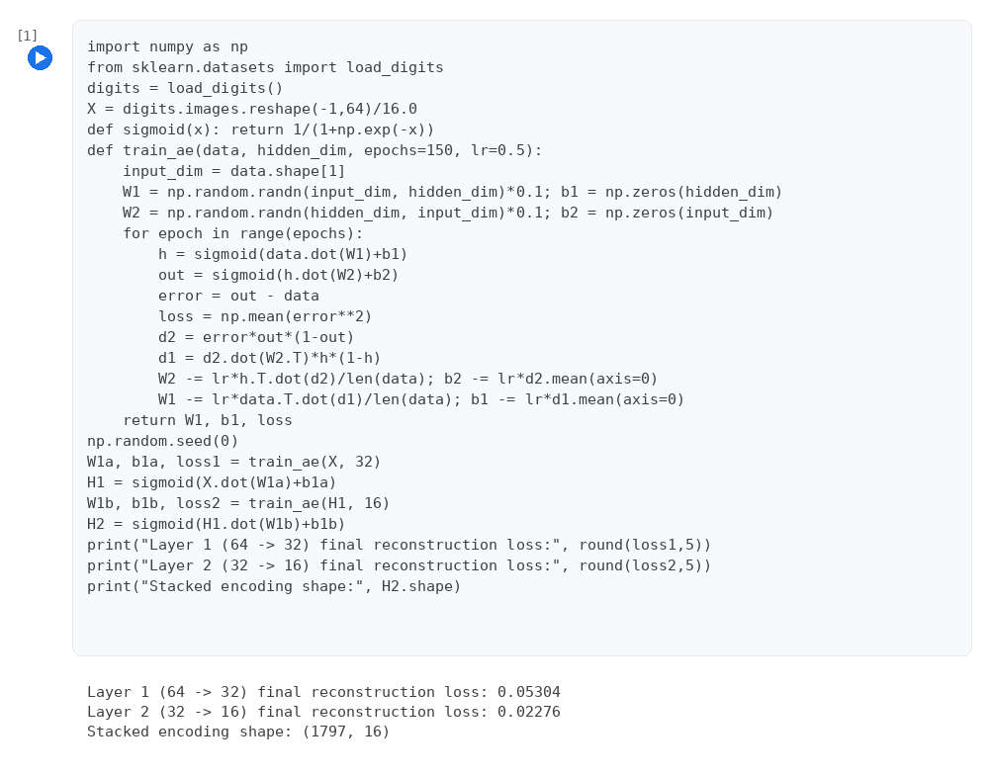

Program 32: Sequence Autoencoder (RNN Encoder with Trained Linear Decoder)
Case Study / Question
A sequence compression system is needed. Implement Sequence Autoencoder.
Program
